# **Jenkins Declarative pipeline Script**

**Pre-requisites**

Step 1 — Launch an Ubuntu(22.04) T2 Large Instance

Install java:

sudo apt update

sudo apt install fontconfig openjdk-17-jre

java -version

openjdk version "17.0.8" 2023-07-18

OpenJDK Runtime Environment (build 17.0.8+7-Debian-1deb12u1)

OpenJDK 64-Bit Server VM (build 17.0.8+7-Debian-1deb12u1, mixed mode, sharing)

Install Jenkins:

sudo wget -O /usr/share/keyrings/jenkins-keyring.asc \

https://pkg.jenkins.io/debian-stable/jenkins.io-2023.key

echo deb [signed-by=/usr/share/keyrings/jenkins-keyring.asc] \

https://pkg.jenkins.io/debian-stable binary/ | sudo tee \

/etc/apt/sources.list.d/jenkins.list > /dev/null

sudo apt-get update

sudo apt-get install jenkins

sudo systemctl start jenkins

sudo systemctl enable jenkins

sudo systemctl status jenkins

Once Jenkins is installed, you will need to go to your AWS EC2 Security Group and open Inbound Port 8080, since Jenkins works on Port 8080.

Now, grab your Public IP Address

<EC2 Public IP Address:8080>

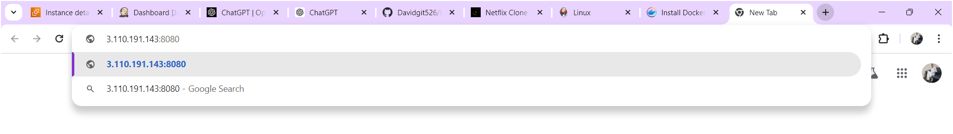

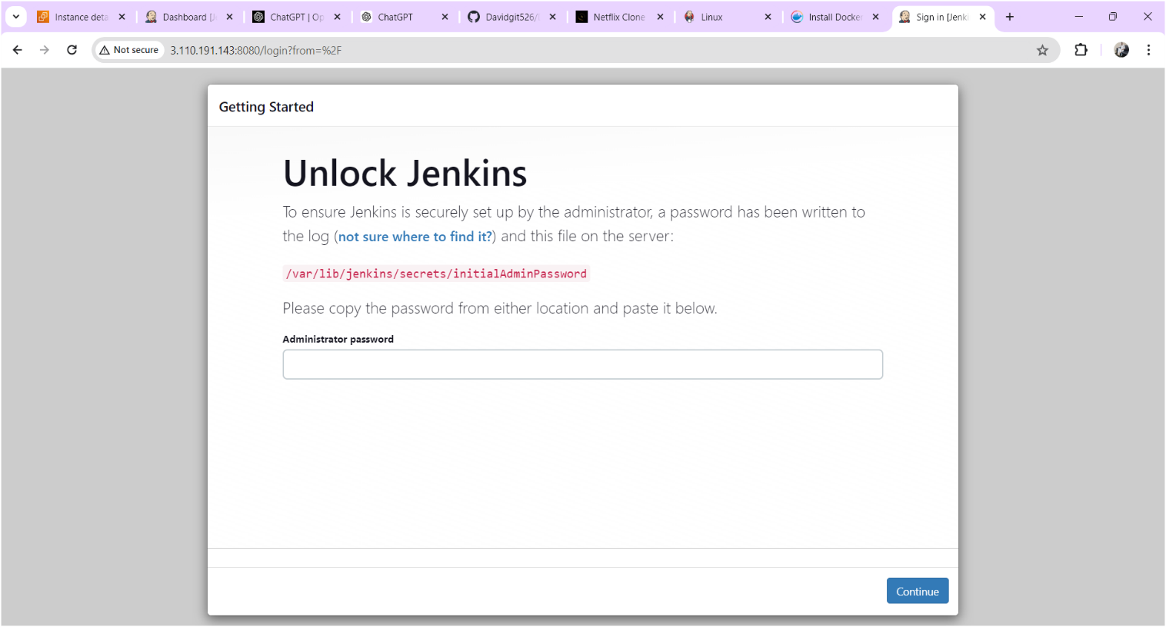

Copy the text which is mentioned in yellow colour box above and paste it using command “cat /var/lib/jenkins/secrets/initialAdminPassword” on your terminal after you will get below output.

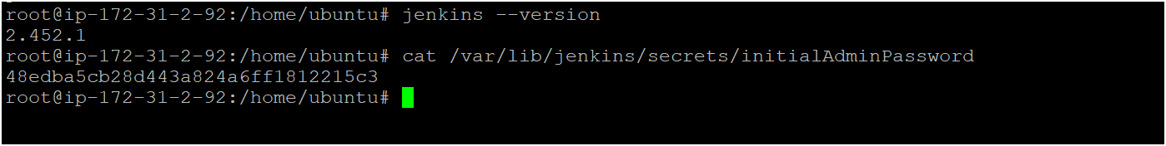

Copy the password for login to jenkins as shown above image

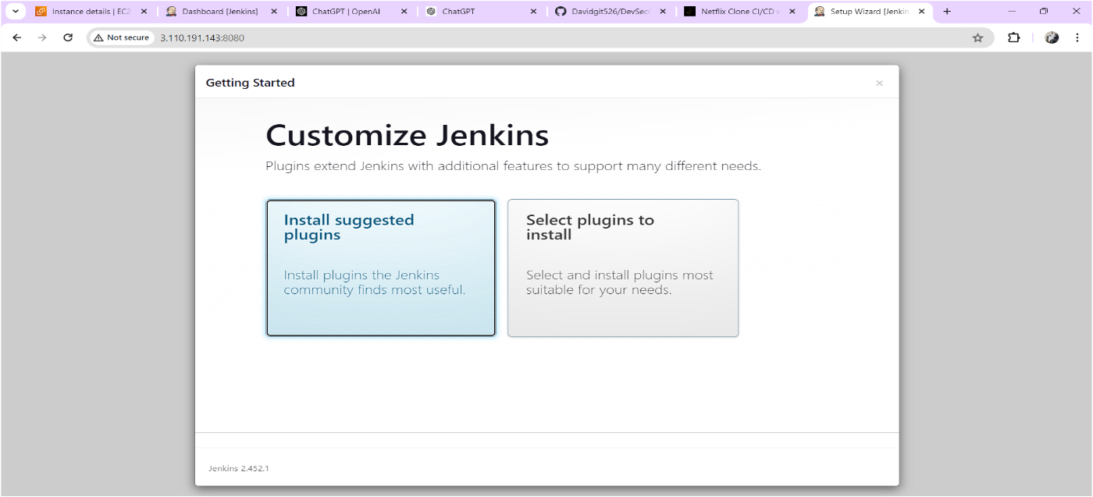

Click on Suggested plugins as shown above image after you will get output as shown below image

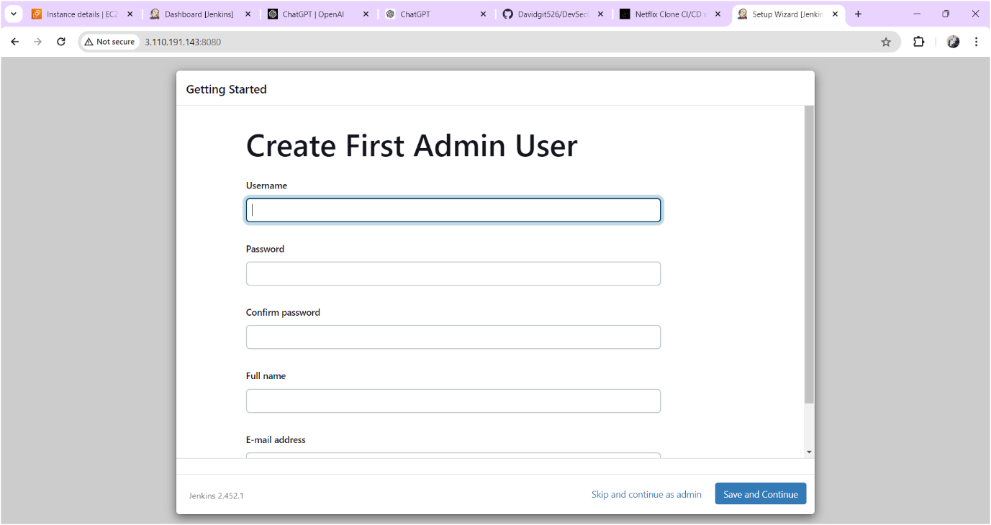

Click on skip and continue as admin

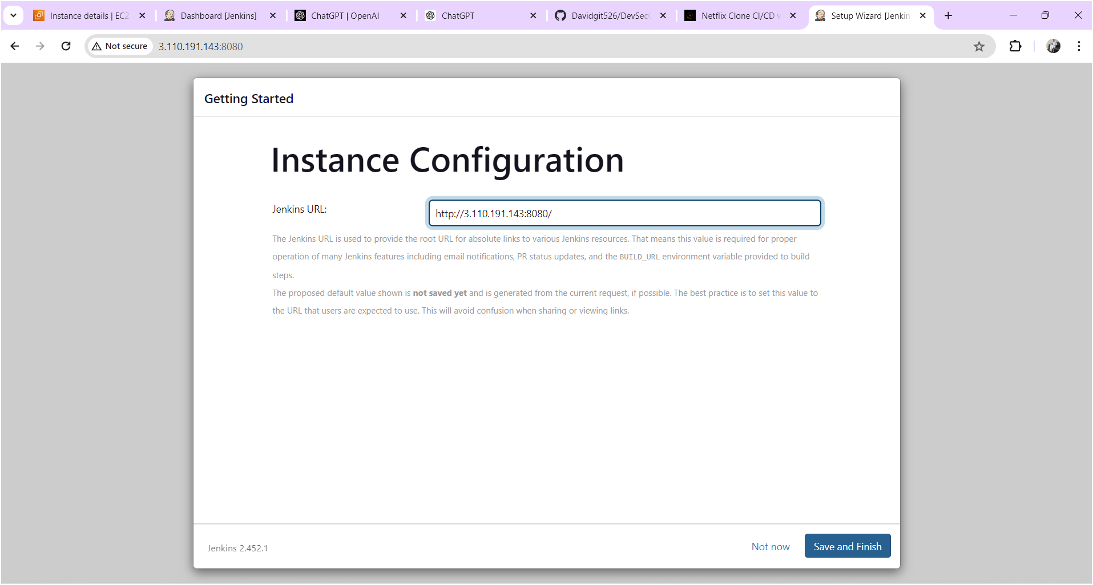

Click on save and finish

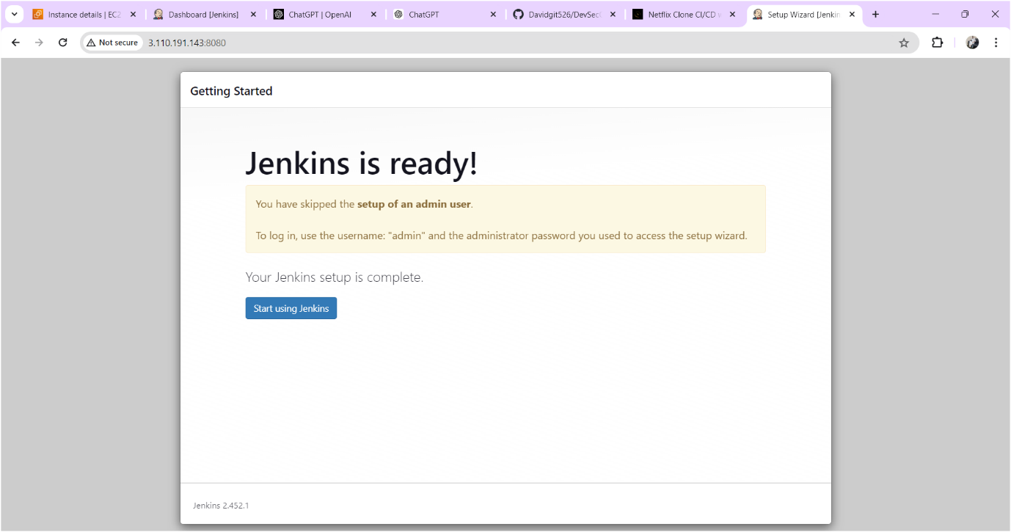

Click on start using jenkins

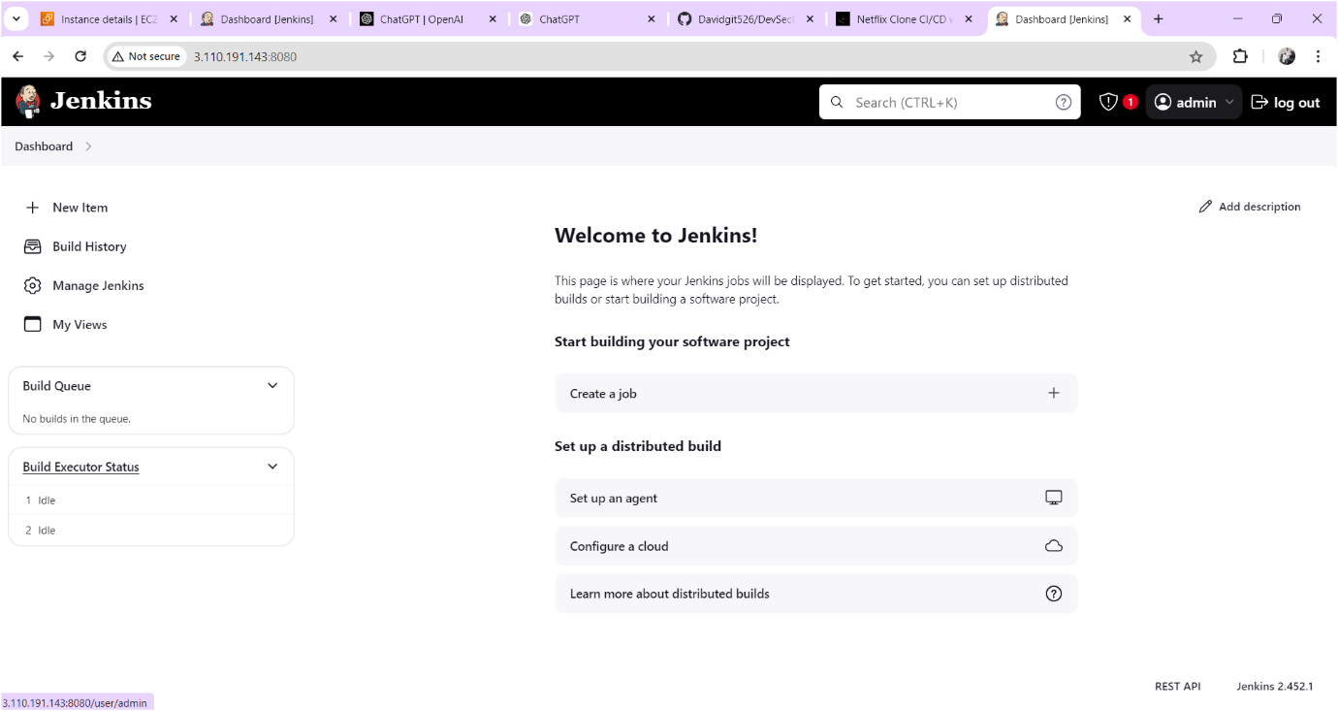

Now you should change the password for that

Click on admin🡪click on configure find password there you can change the password whatever you want. Output sown as below image

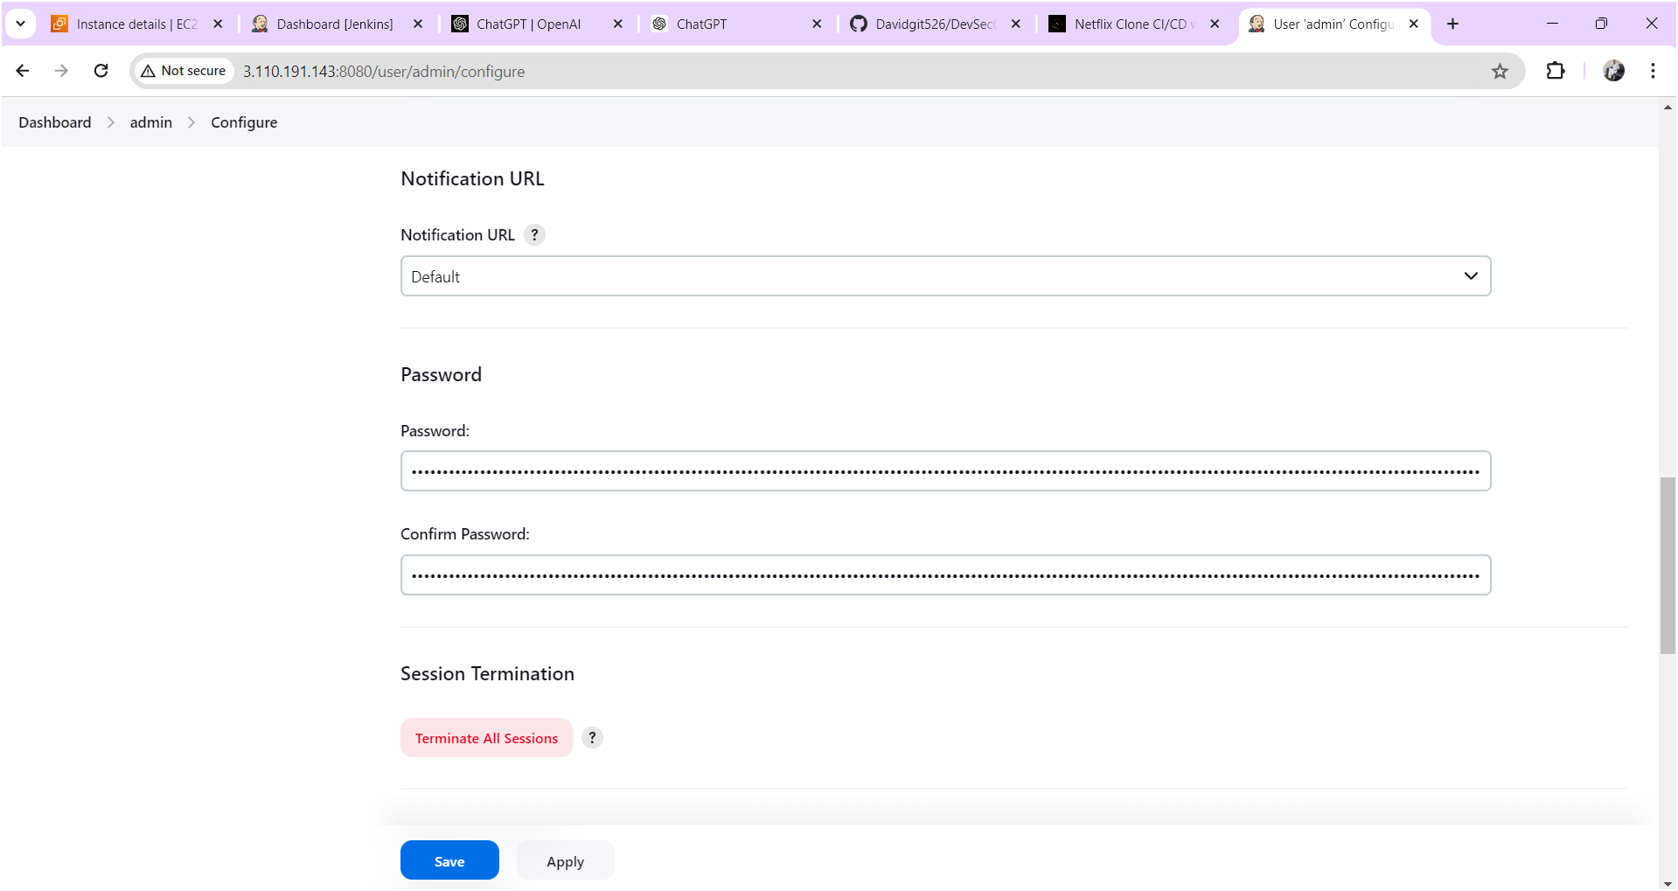

After changing the password click on **apply** and **save** after output will come as shown below image.

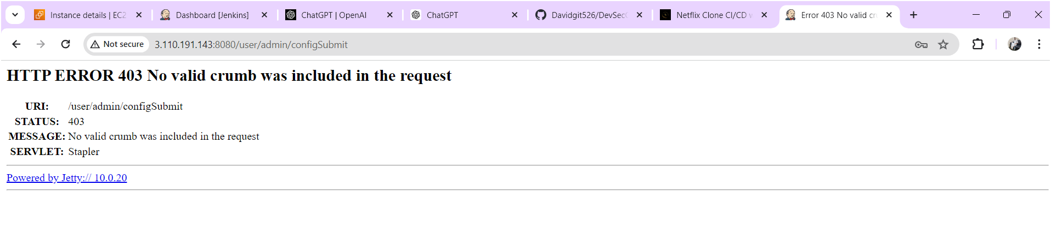

Now refresh the page after output will come as shown below image

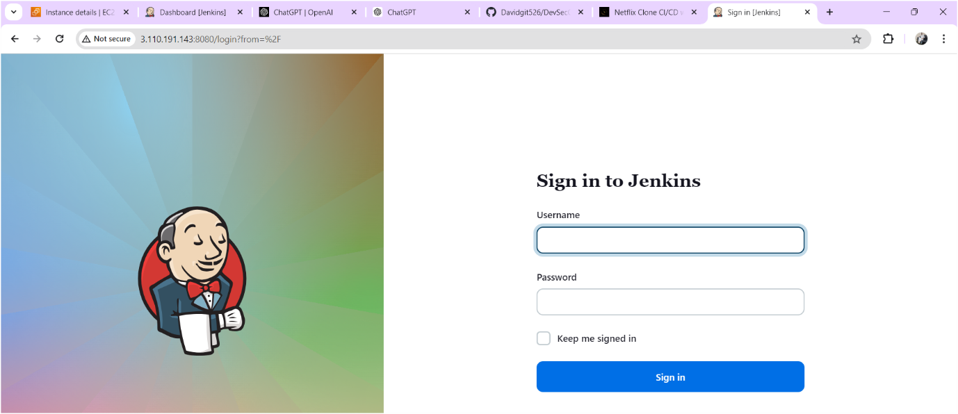

Login to the jenkins with your updated credentials after you will get jenkins home page as shown below.

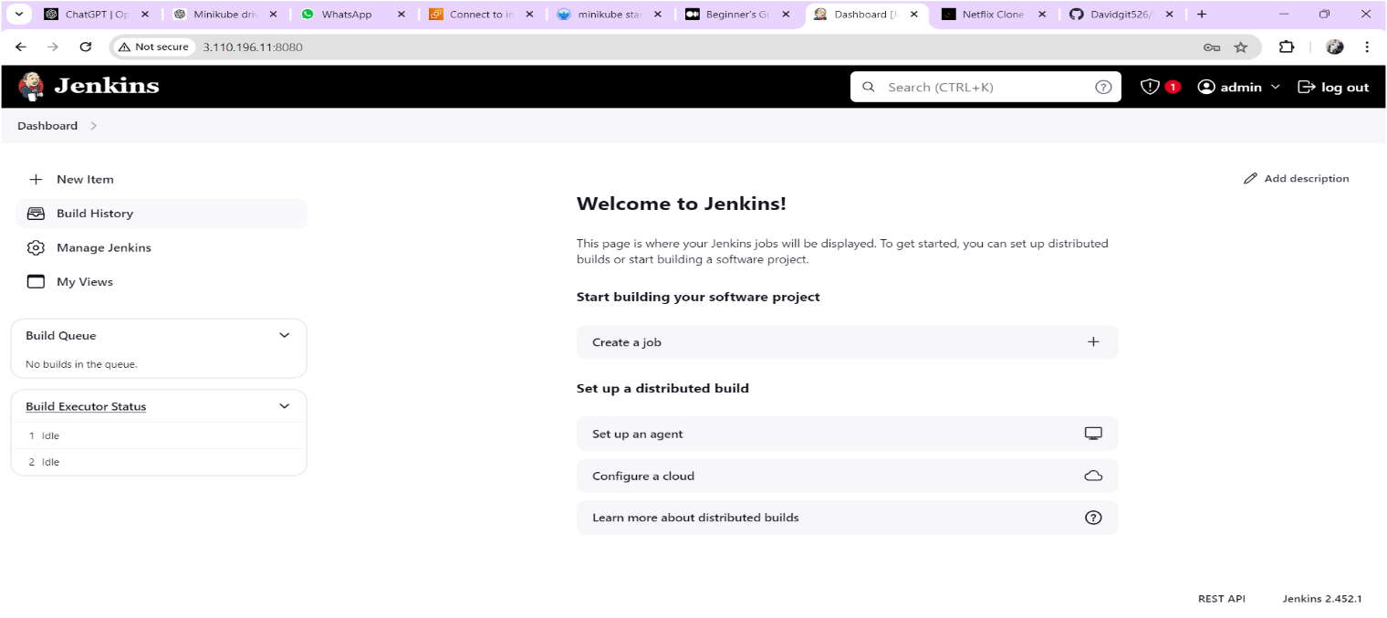

**Install SonarQube:**

Launch an Ubuntu(22.04) T2 medium Instance or you can install on jenkins server only (Note: If jenkins server running slowly you need to create another instance and install sonarqube.)

**Set up Docker on the EC2 instance:**

sudo apt-get update

sudo apt-get install docker.io -y

sudo usermod -aG docker $USER # Replace with your system's username, e.g., 'ubuntu'

newgrp docker

sudo chmod 777 /var/run/docker.sock

docker run -d --name sonar -p 9000:9000 sonarqube:lts-community

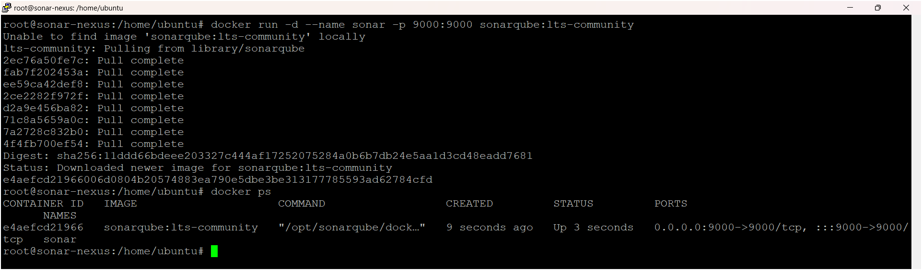

To access:

Need to open port number 9000 in security groups

publicIP:9000 (by default username & password is admin)

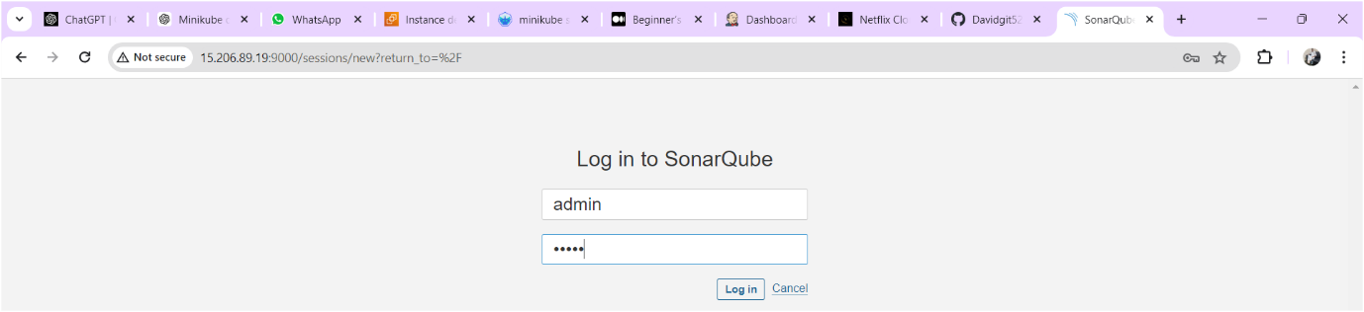

After login you need to change the password as shown below image

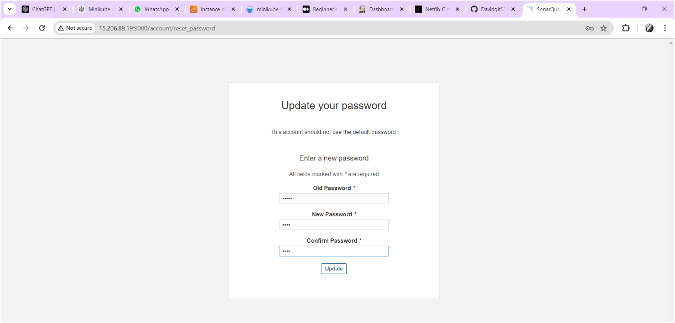

Sonarqube home page is as shown below

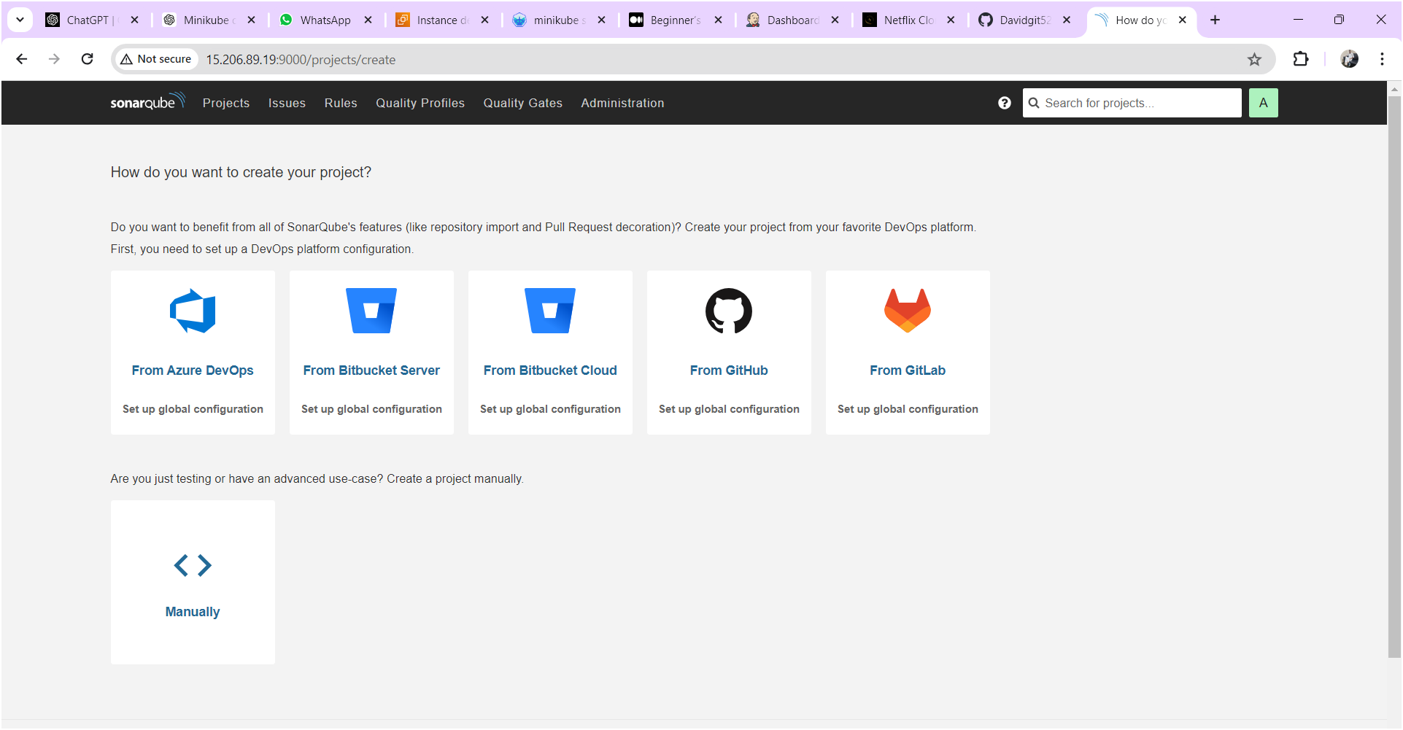

## **Configure Sonar Server in Manage Jenkins**

Goto your Sonarqube Server. Click on Administration → Security → Users → Click on Tokens and Update Token → Give it a name → and click on Generate Token

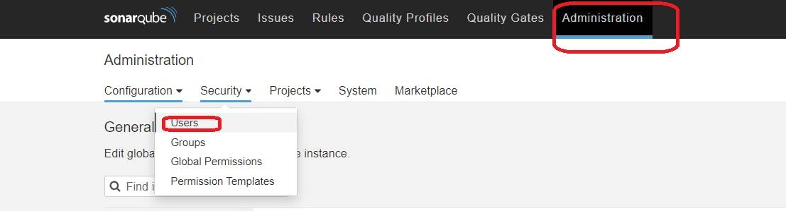

click on update Token

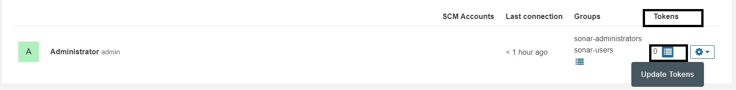

Give name for token and click on generate then token will generate and keep it save some other place for future use.

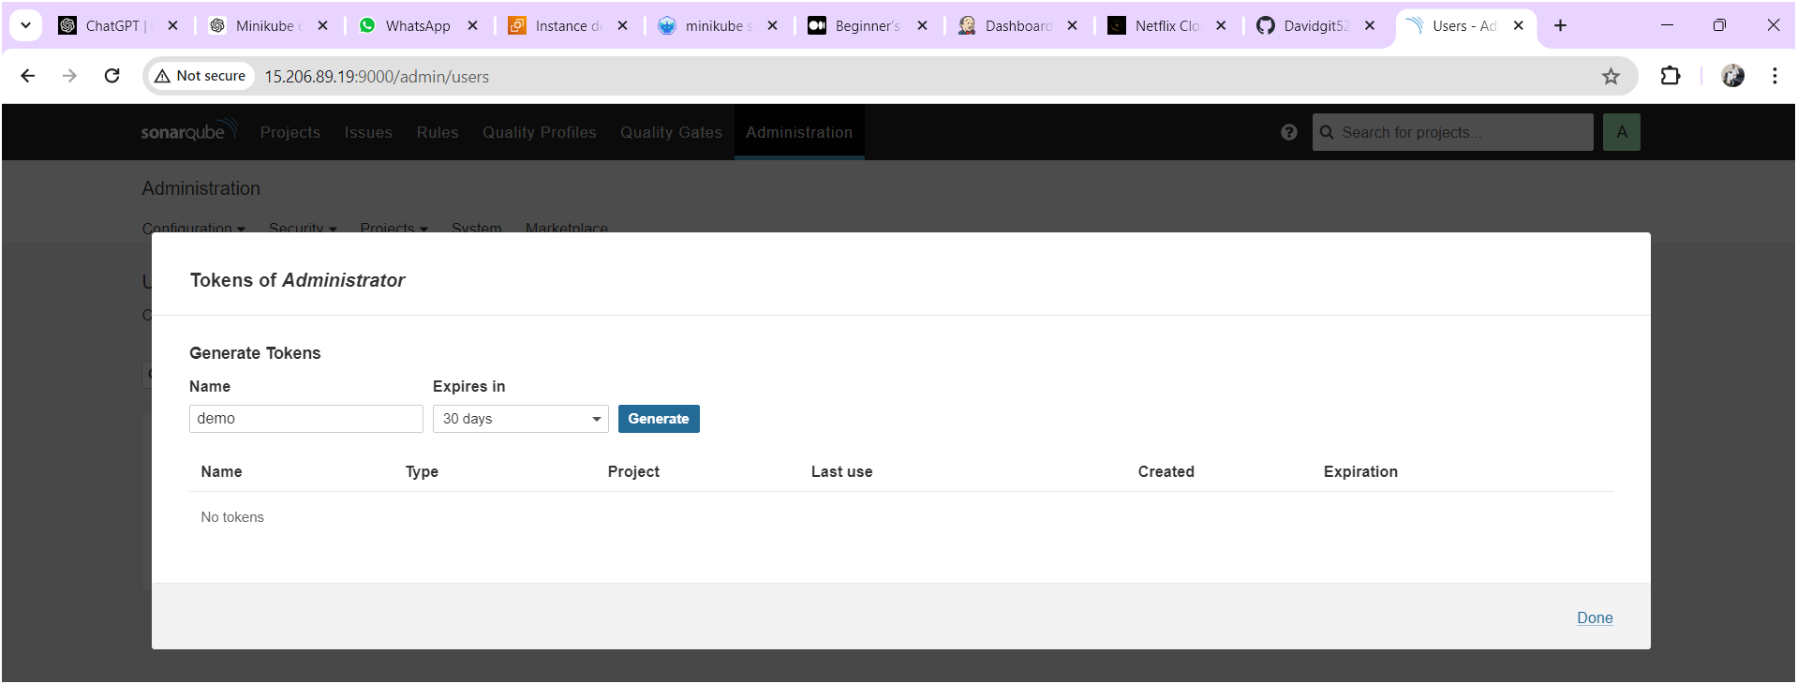

Copy the token save it at somewhere

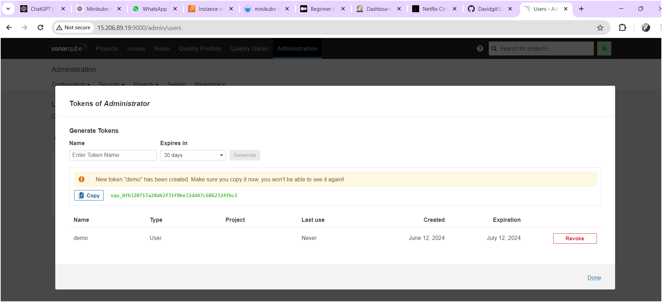

Goto Jenkins Dashboard → Manage Jenkins → Credentials → Add Secret Text. It should look like this.

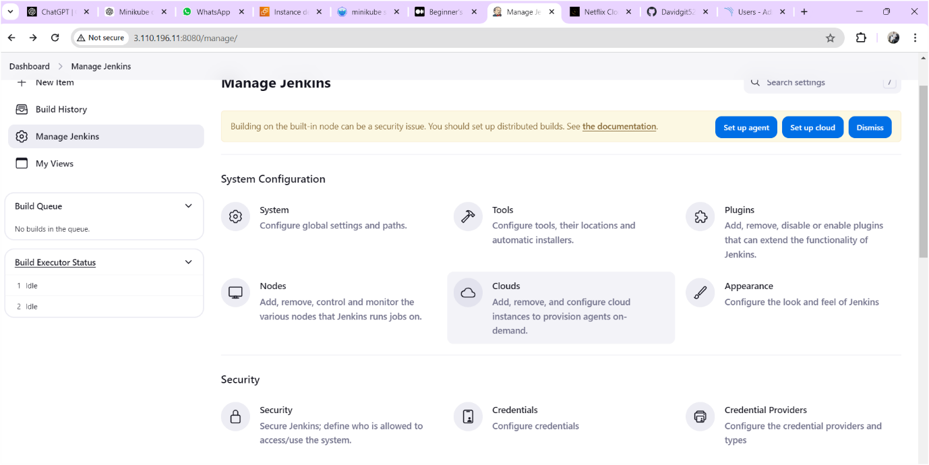

Click on “system” as shown below image

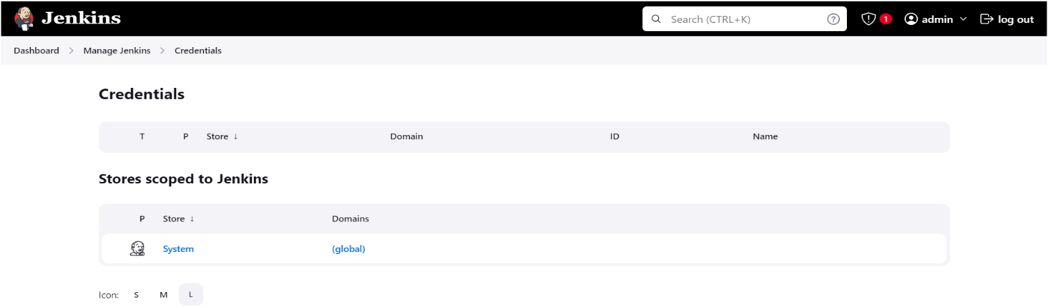

Click on “Global Credentials” as shown below image

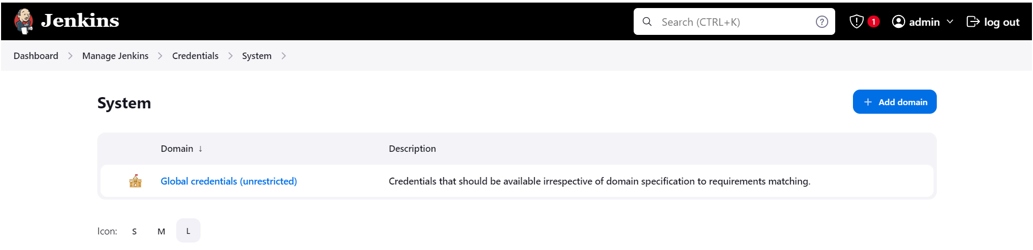

Here paste the token and give id and description as “sonar-token like below image.

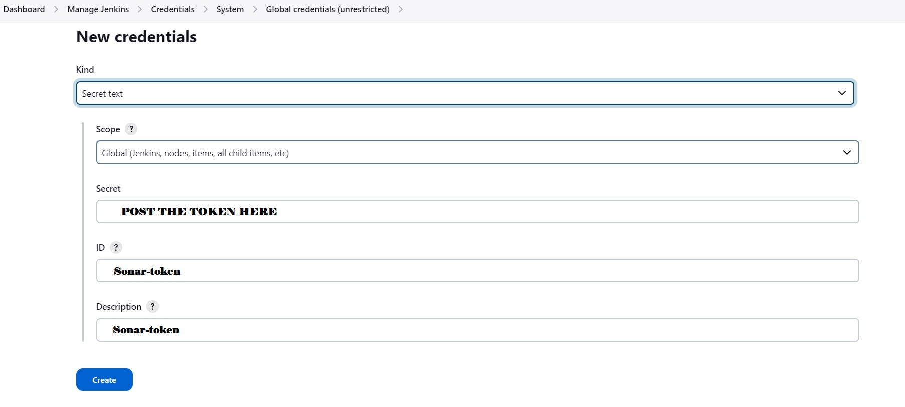

You will this page once you click on create

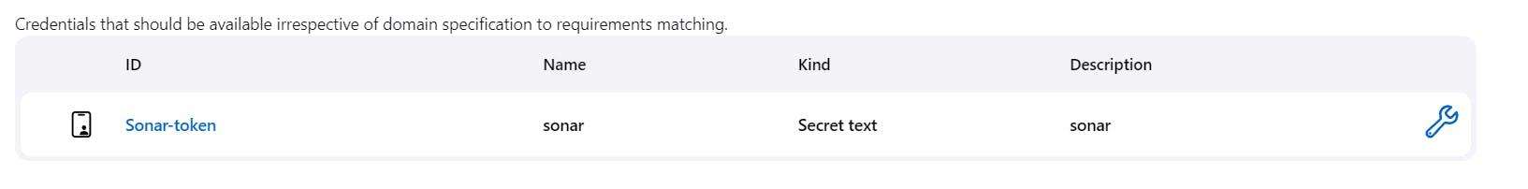

Now, go to Dashboard → Manage Jenkins → System and Add like the below image.

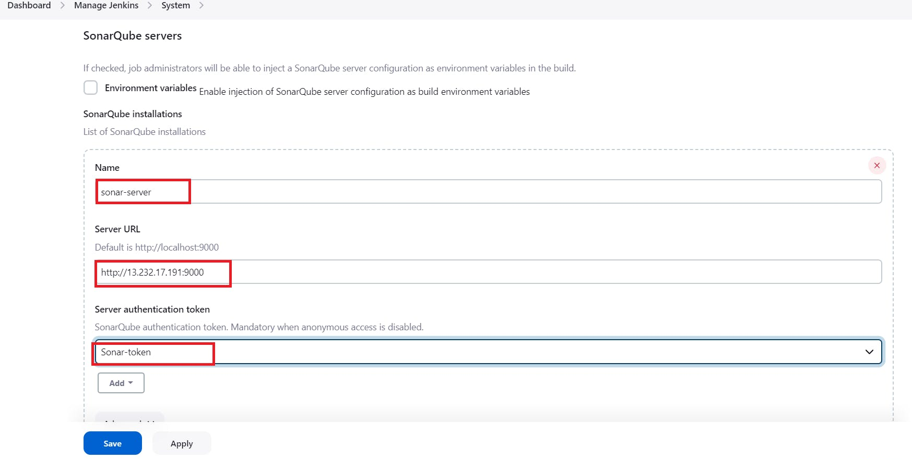

Click on Apply and Save

**The Configure System option** is used in Jenkins to configure different server

**Global Tool Configuration** is used to configure different tools that we install using Plugins

We will install a sonar scanner in the tools.

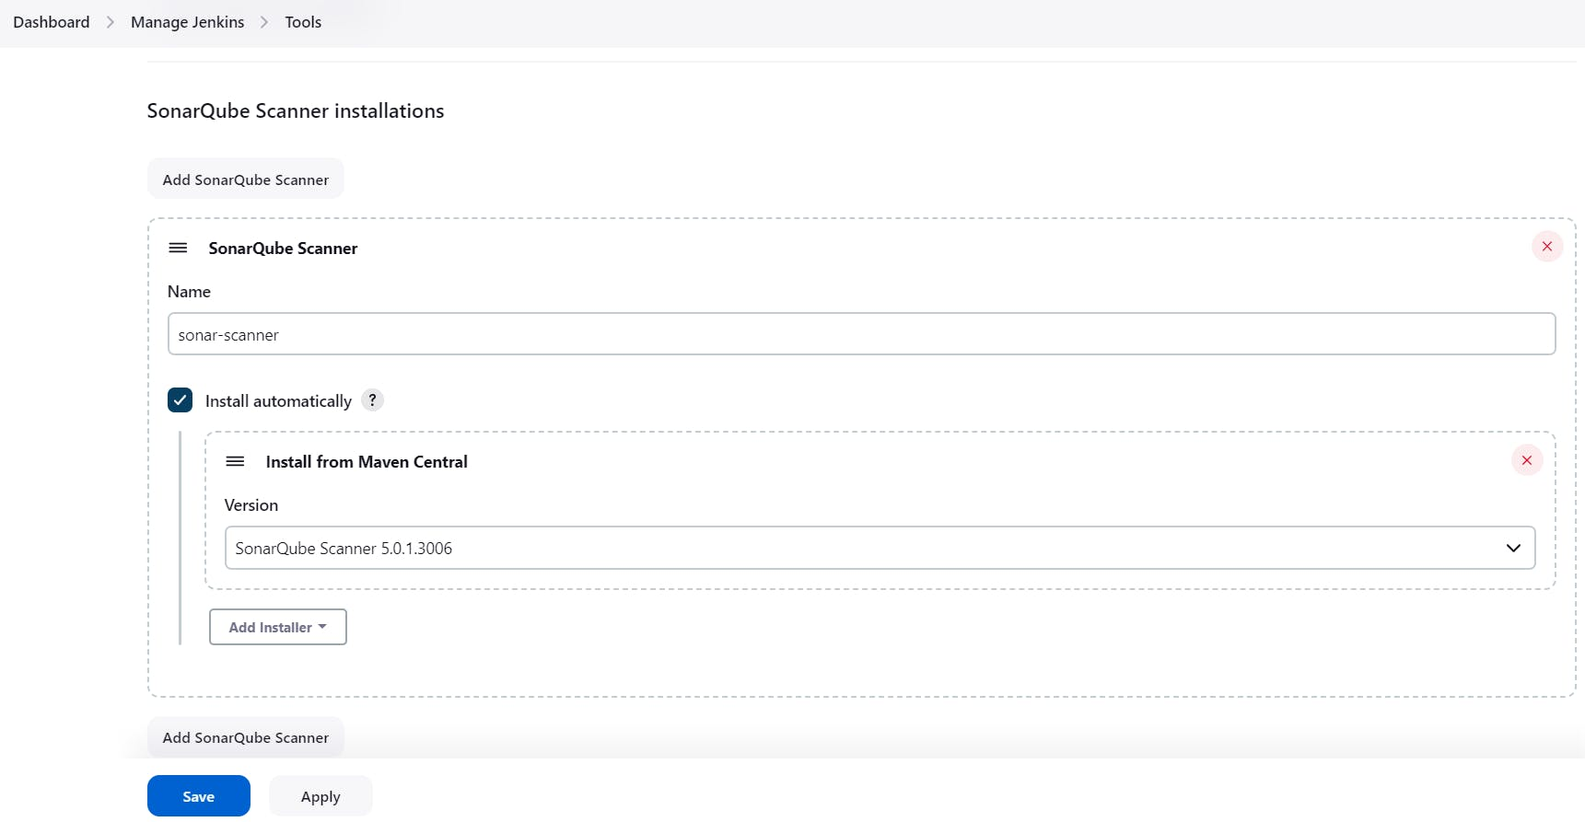

Next create a project in sonarqube server go to projects🡪manually as shown below image.

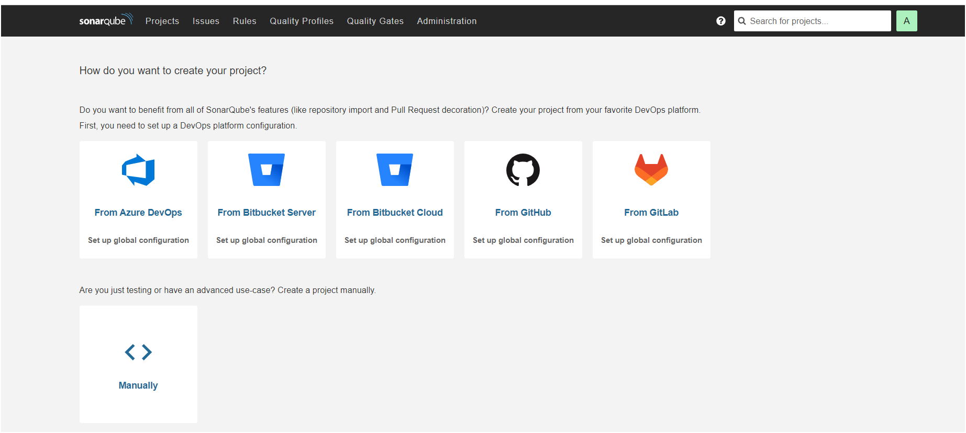

After clicking on “manually” you will get as shown below image

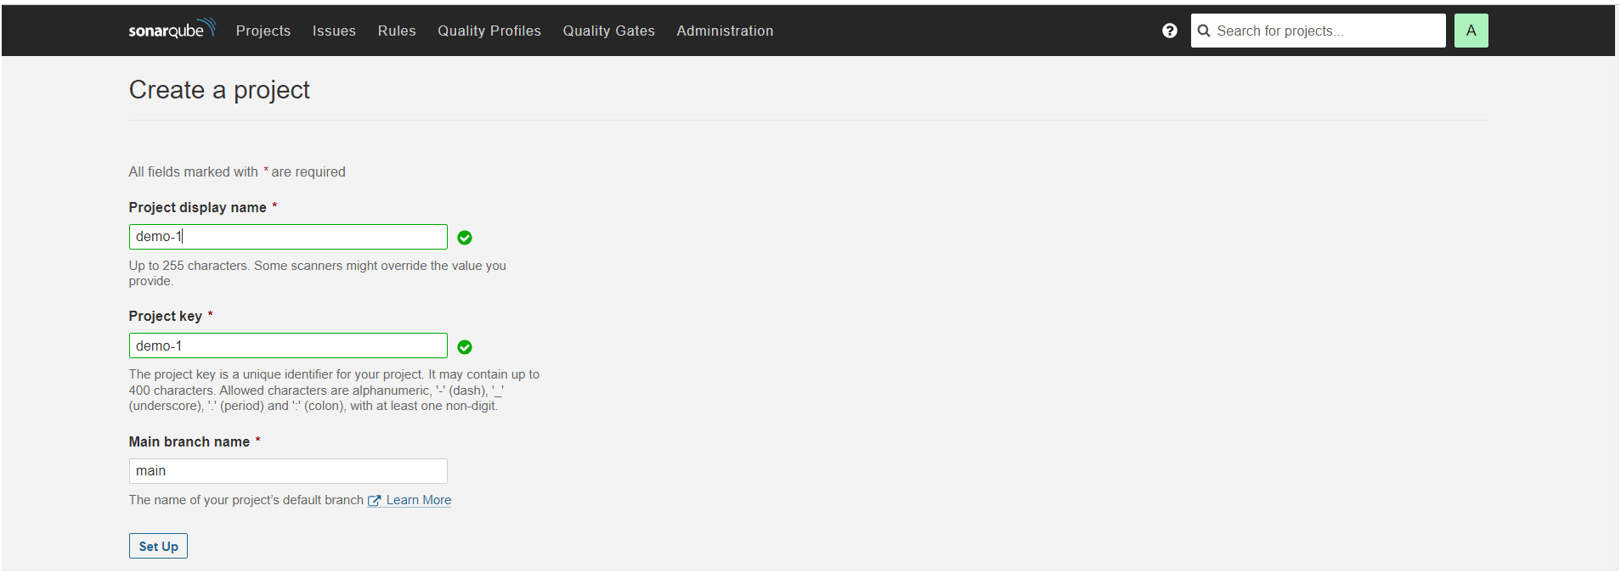

After click on “set up” you will get as shown below image.

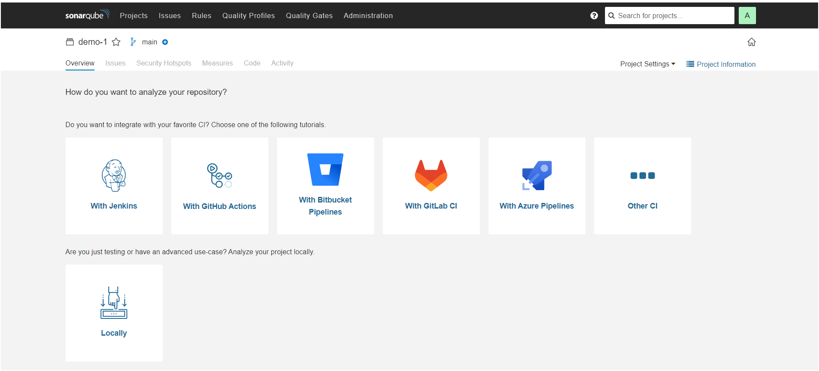

Once clicked on “locally” you will get next page as shown below after click on existing token and paste token here which we have generated a token after click on “continue”.

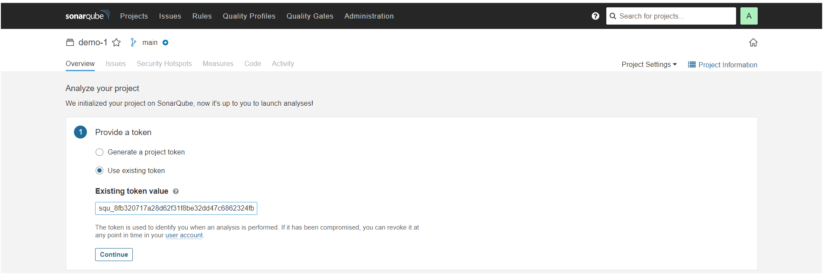

Next you will get page as shown below image

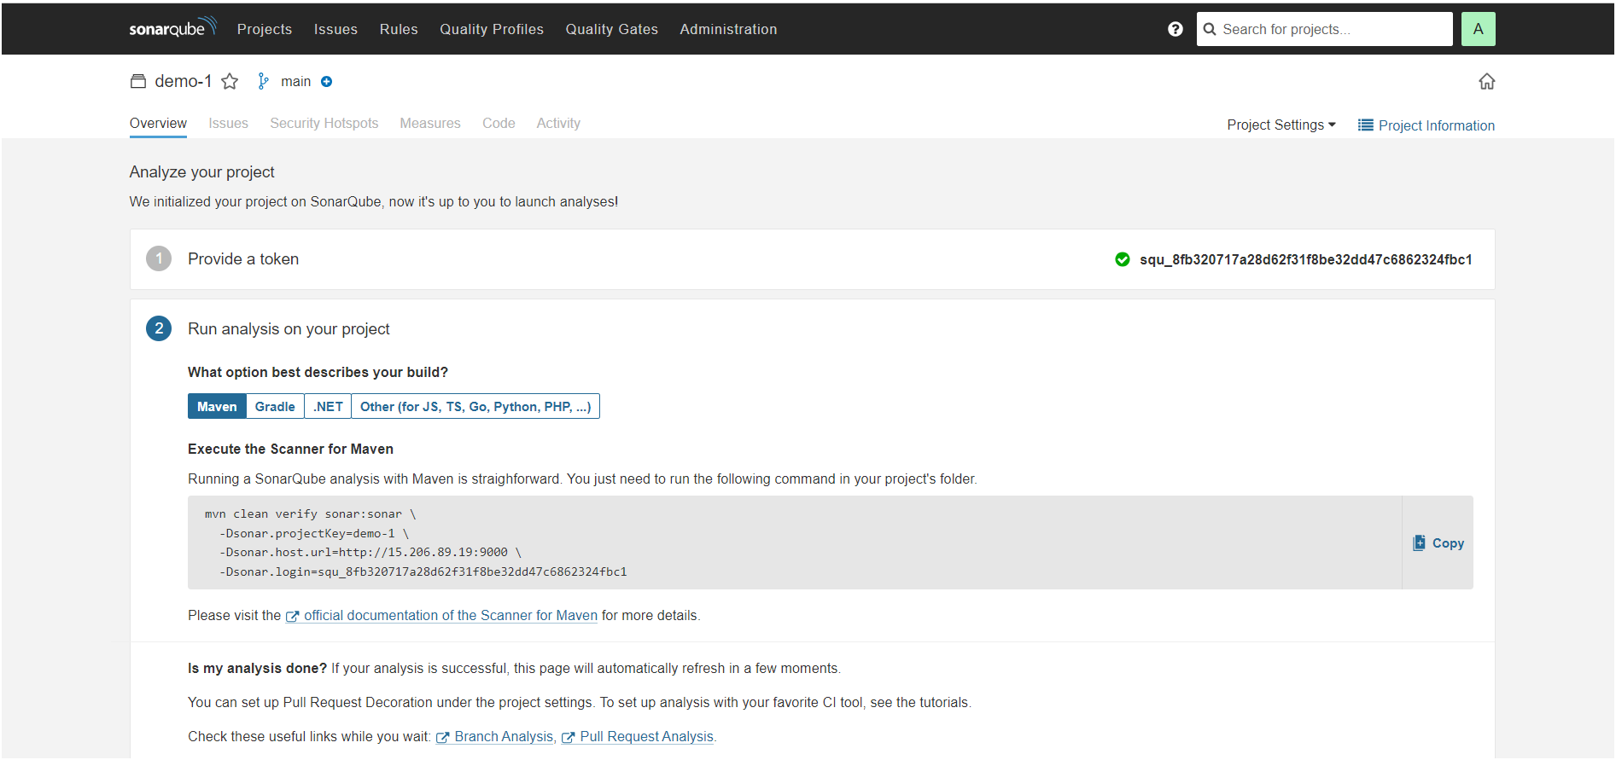

## **Install Plugins**

1. Eclipse Temurin Installer
2. SonarQube Scanner
3. Maven Integration
4. Pipeline Maven Integration
5. Deploy to Container
6. Nexus Artifact Uploader

**To install plugins, go to Dashboard🡪Manage Jenkins🡪Available Plugins**

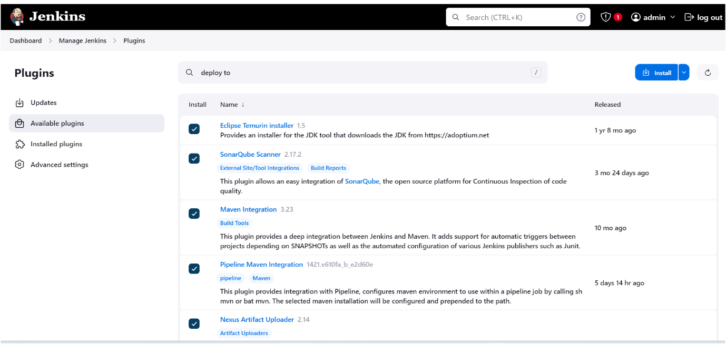

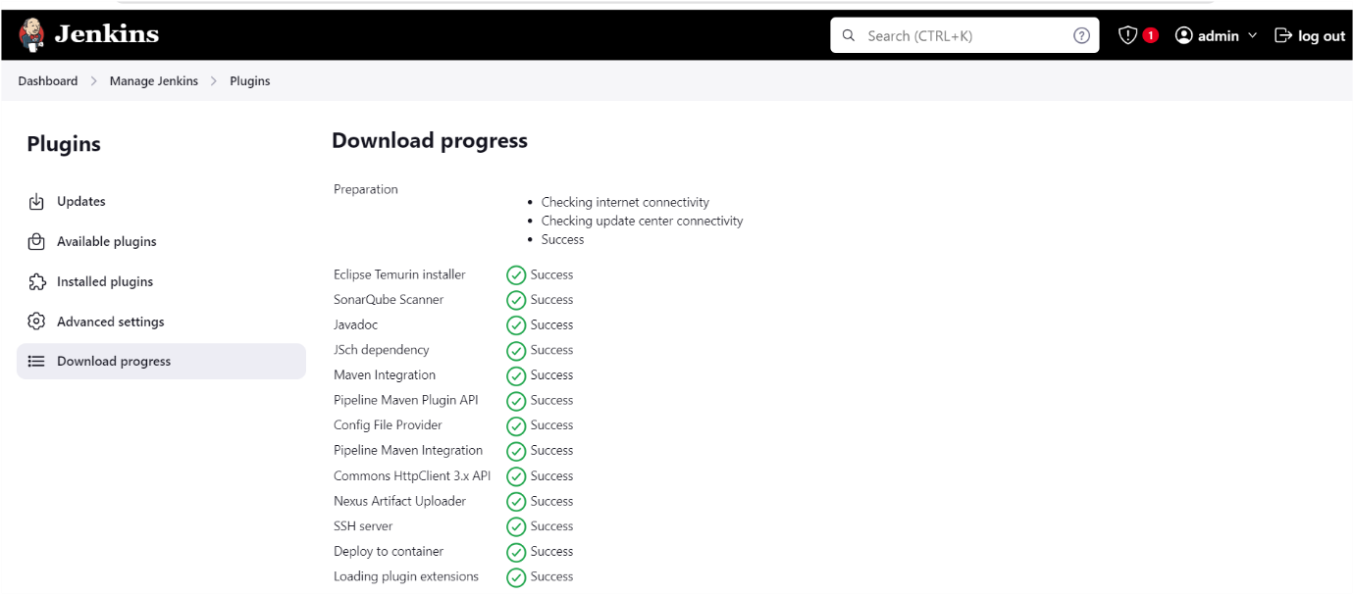

Configure **jdk** go to **manage Jenkins🡪tools** as shown below images

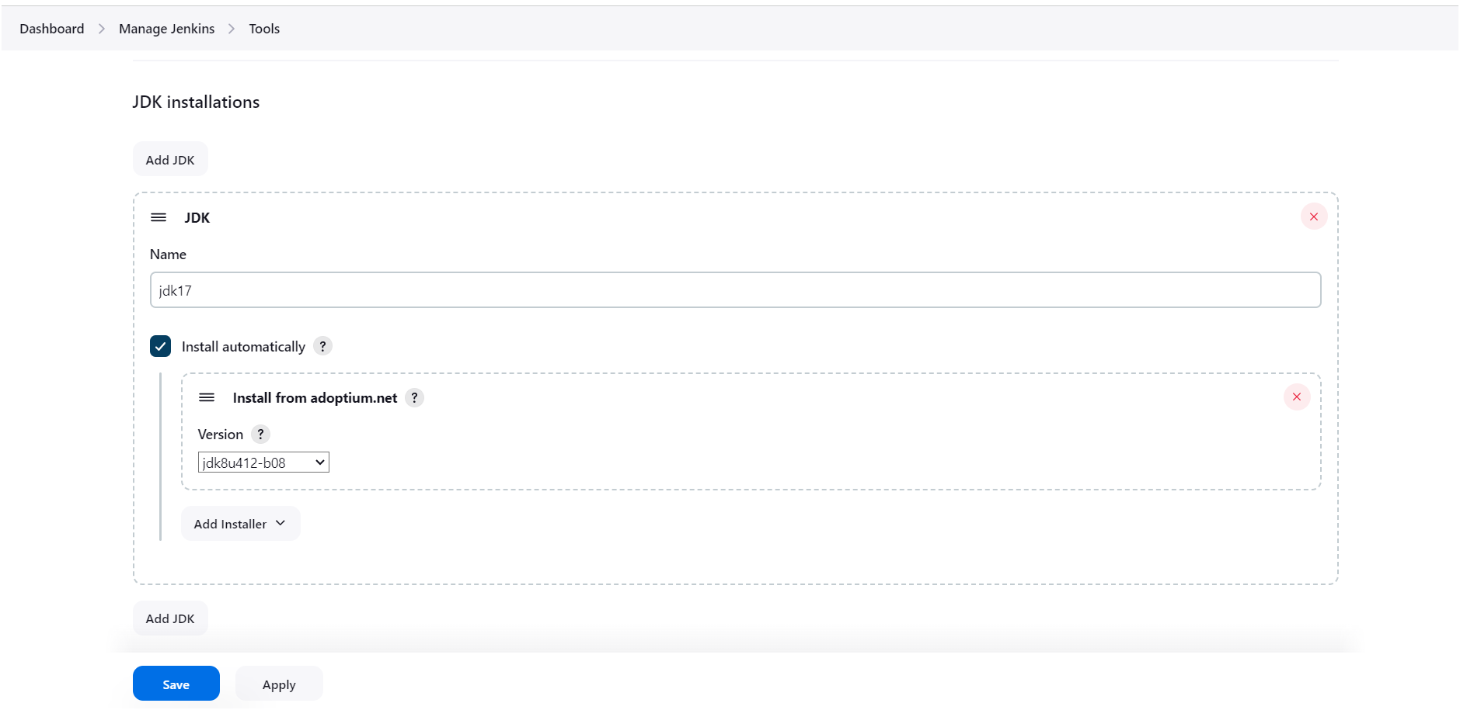

Click on apply and save☝️

Configure **Sonarqube go to manage Jenkins🡪tools** as shown below image👇

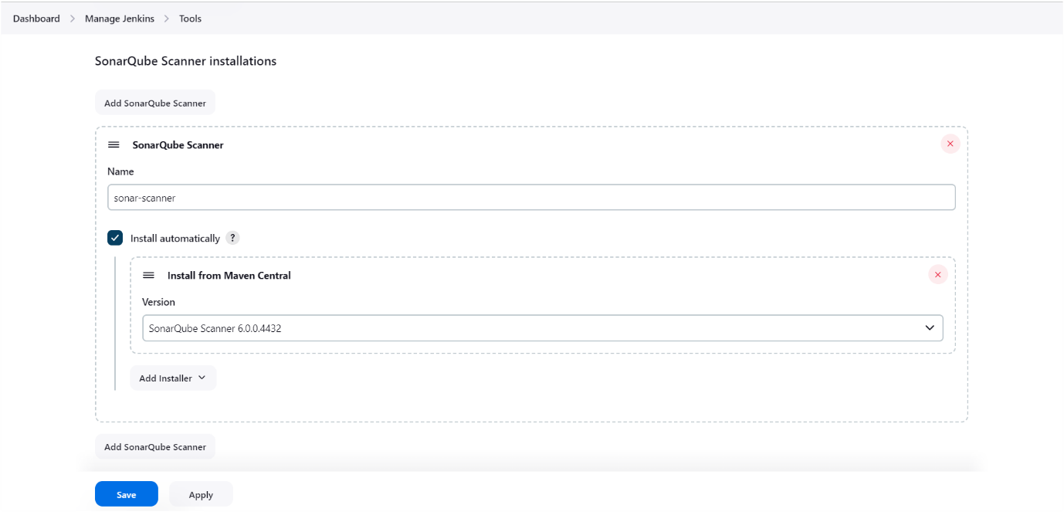

Click on apply and save☝️

Configure **Sonarqube go to manage Jenkins🡪systems** as shown below image👇, in server URL you need to provide your sonarqube server URL

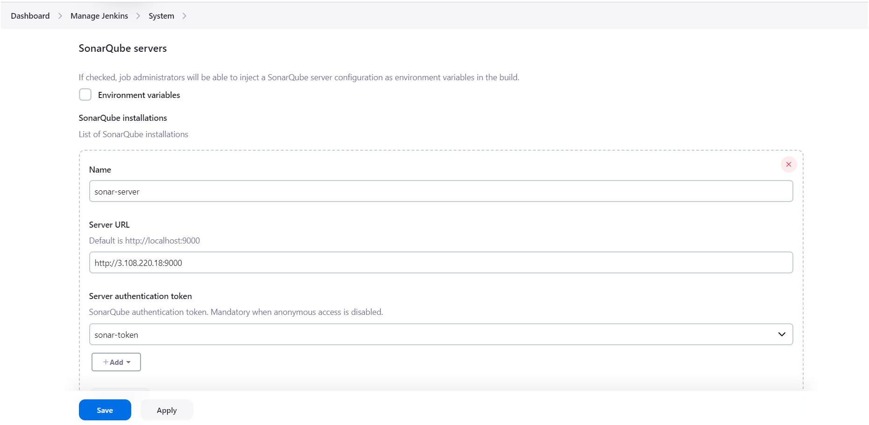

Click on apply and save☝️

Configure **maven** go to **manage jenkins🡪tools** as shown below image👇

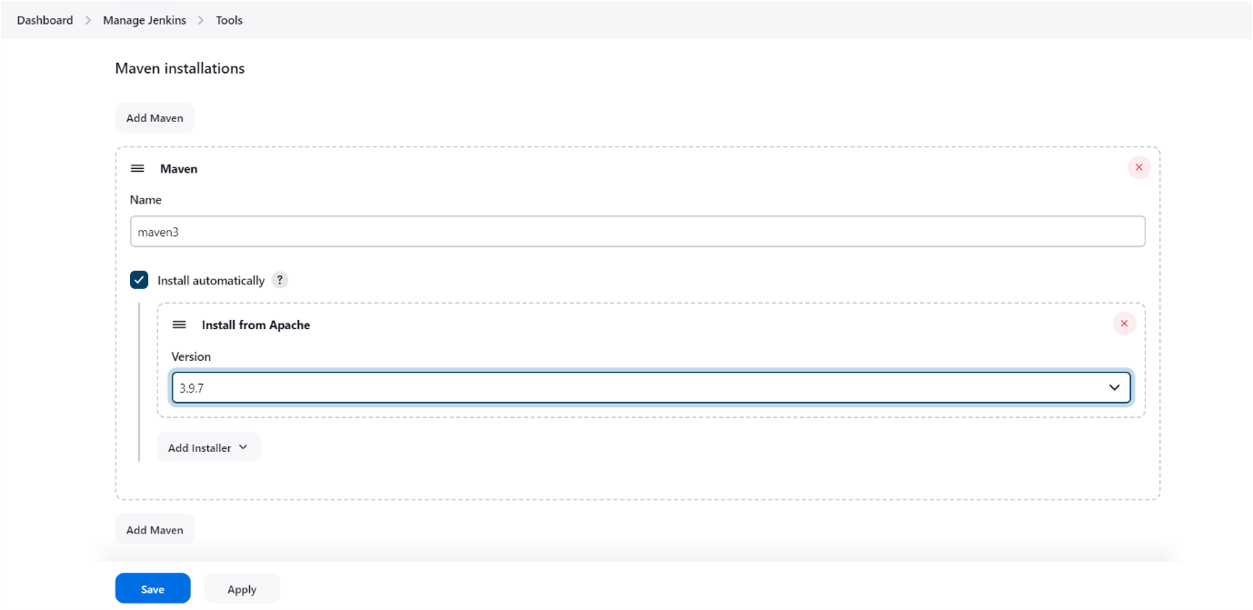

Click on apply and save☝️

Before Configure nexus you have to deploy nexus application inside the container as shown below👇

**Install nexus server**

docker run -d --name nexus -p 8081:8081 sonatype/nexus3

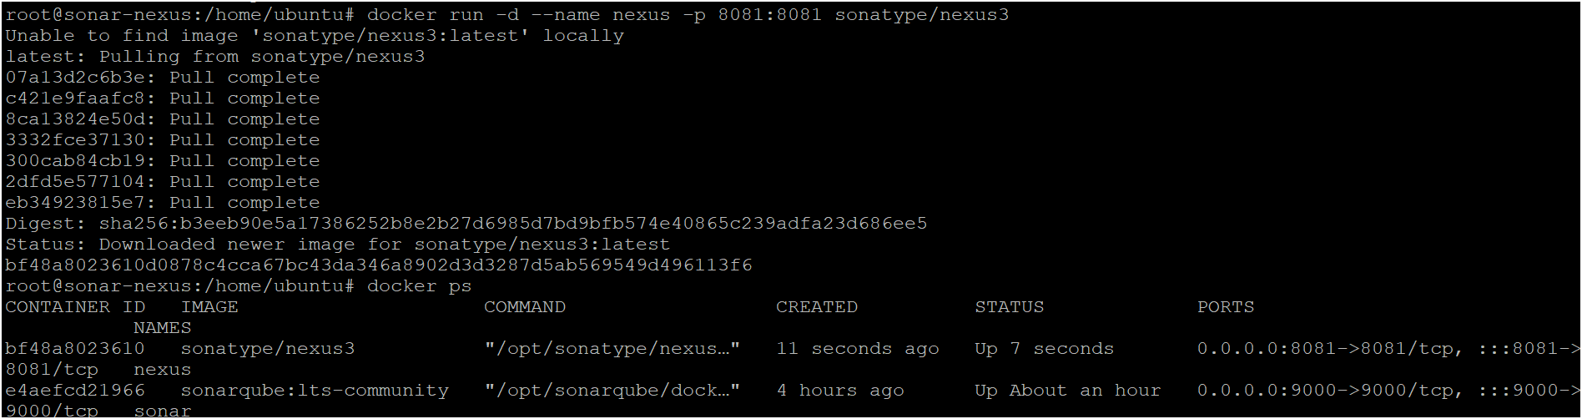

To access:

Need to open port number 8081 in security groups

publicIP:9000 by default username is admin and for password follow below steps 👇

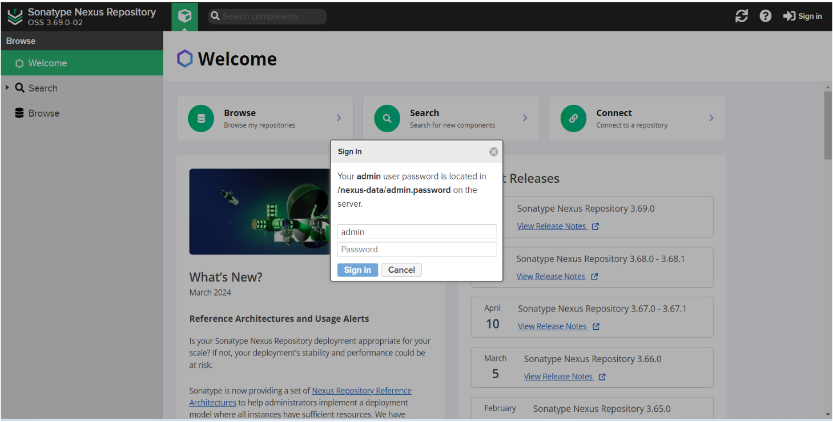

To get password execute follow commands as shown below👇

docker exec -it nexus cat /nexus-data/admin.password🡪 run that commands in your server where you have deployed nexus server as shown below👇



This is the password for nexus copy and login to the nexus server as shown below image

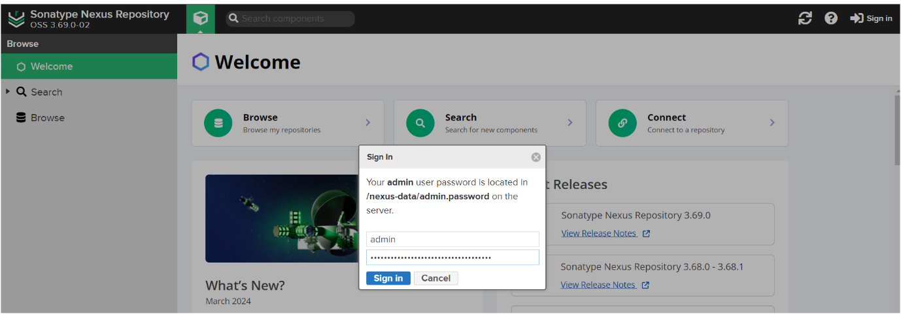

Nexus home page will appear as shown below

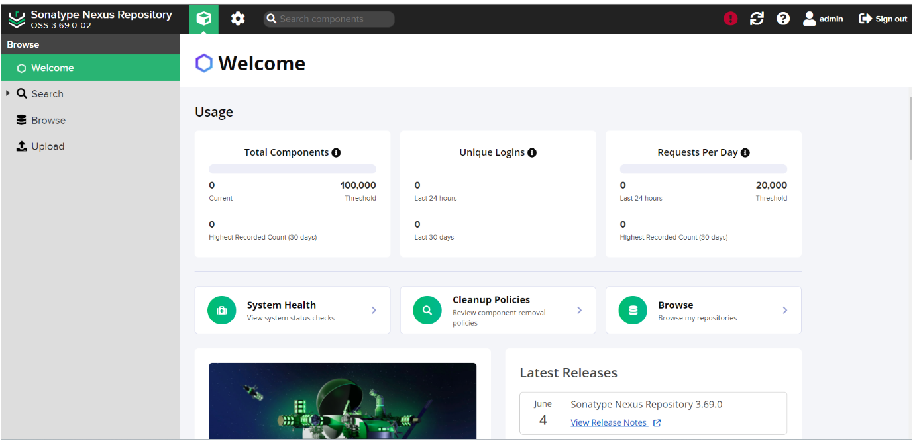

Configure or set up nexus in jenkins go to **manage jenkins🡪go to manged files** as shown below image👇

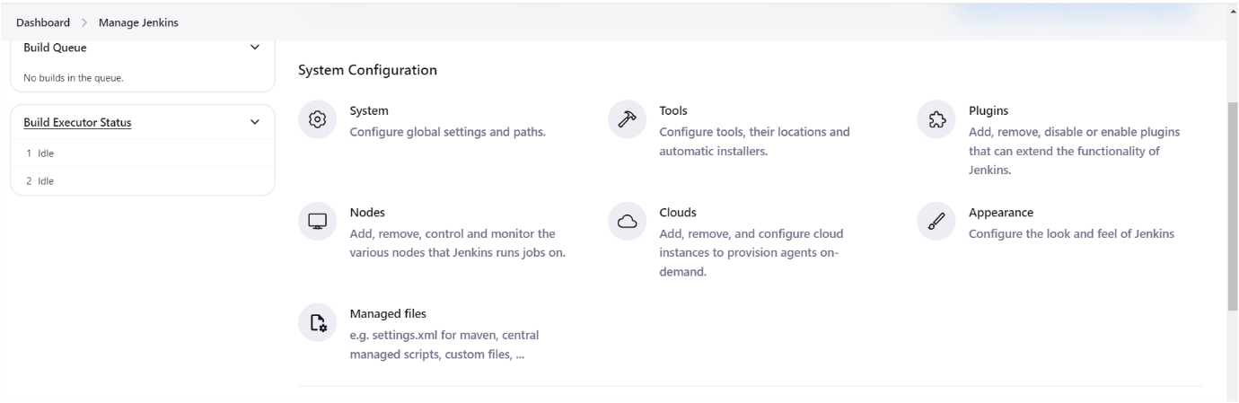

Click on **Add a new config**🡪click on **Global Maven settings.xml** as shown below image

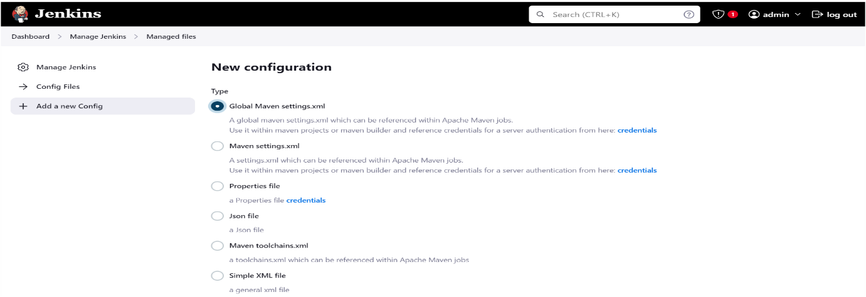

Next scroll down go to ID 🡪 give name as “global-settings” as shown below image👇

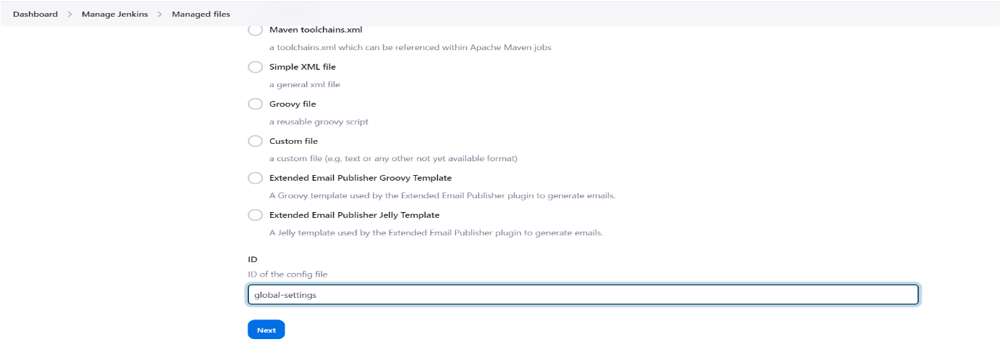

Click on next☝️

Next provide **credentials of nexus server** (give your nexus credentials) as shown below image👇

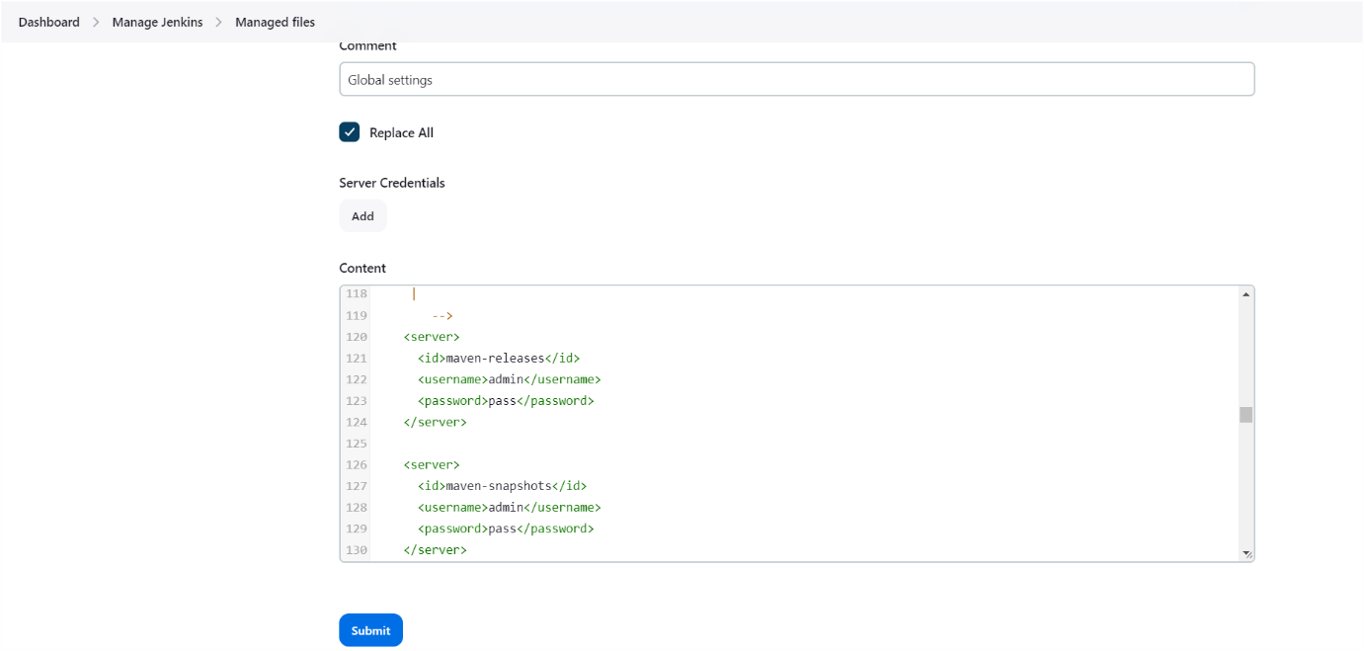

Click on submit☝️

Next need to update maven-snapshots and maven-releases URLs in your pom.xml file as shown below image👇

For getting maven-releases url follow below steps👇

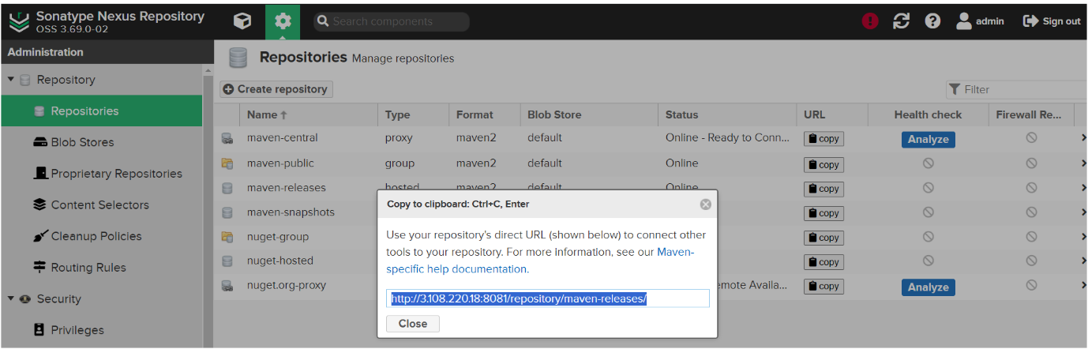

Update the above url in your pom.xml as shown below image 👇

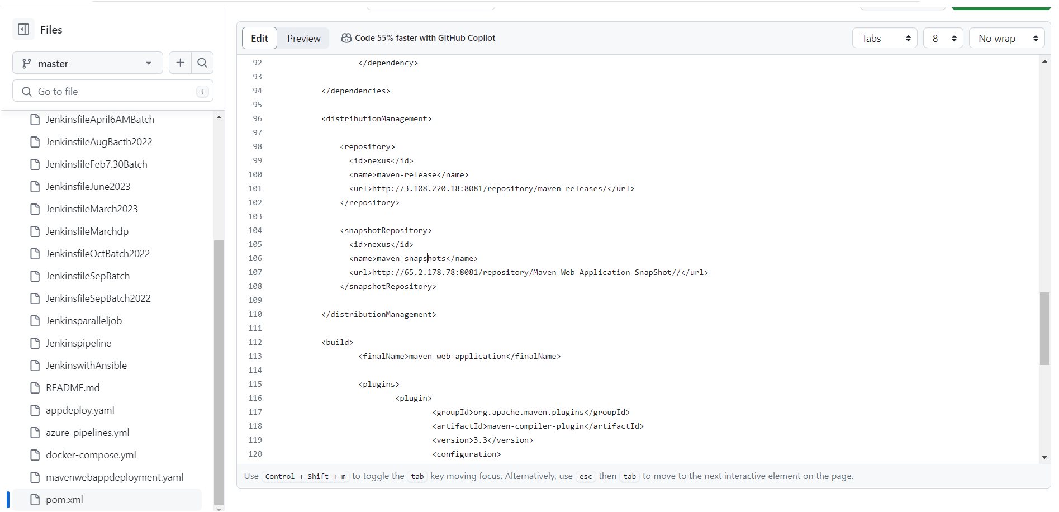

For getting maven-snapshots URL follow below steps👇

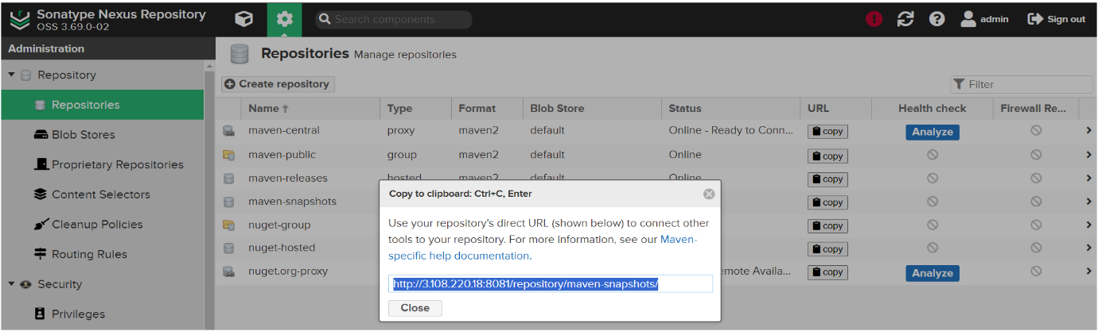

Update the above URL in your pom.xml as shown below image 👇

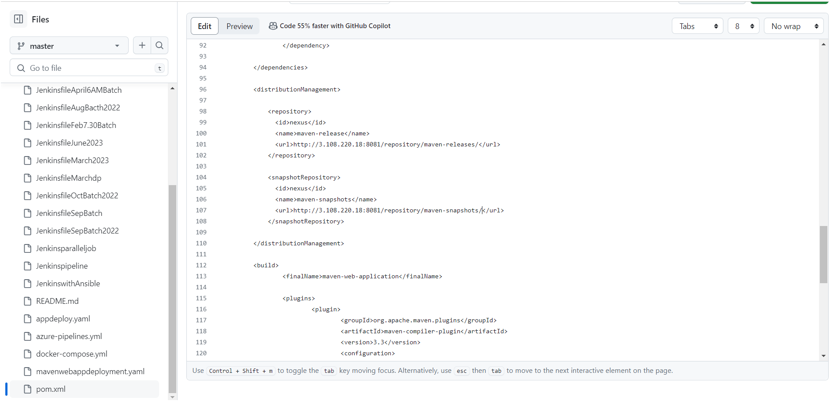

Next you need to commit the changes as shown below image at your GitHub repository👇

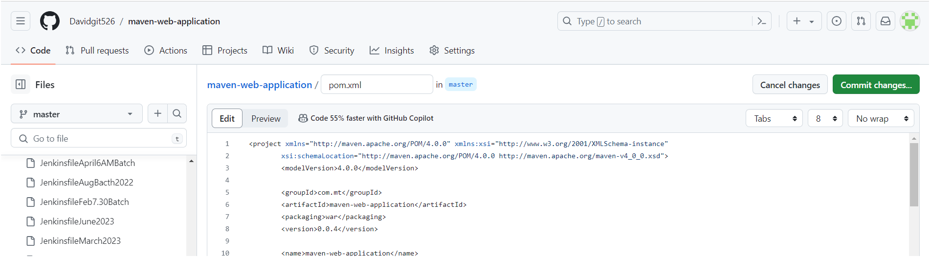

**Let’s create a pipeline**

Firstly, we need to create a job or item by clicking on “new item” as shown below image

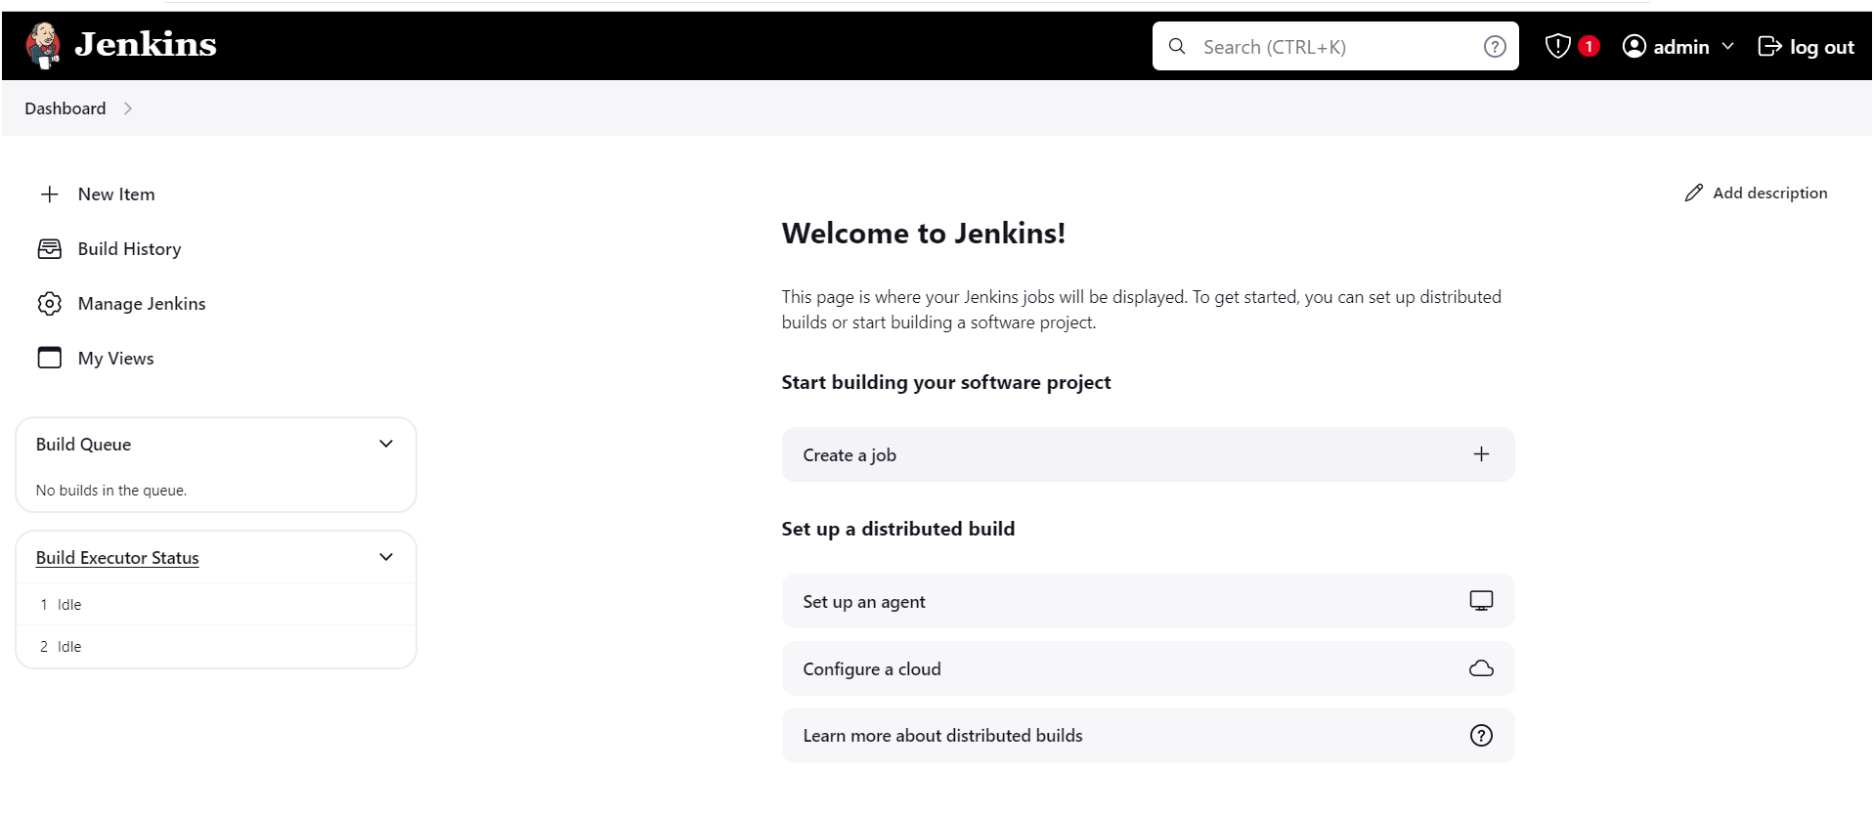

Next, we need to select pipeline type as shown below iamge.

Give name🡪select “pipeline”🡪click on “ok”

